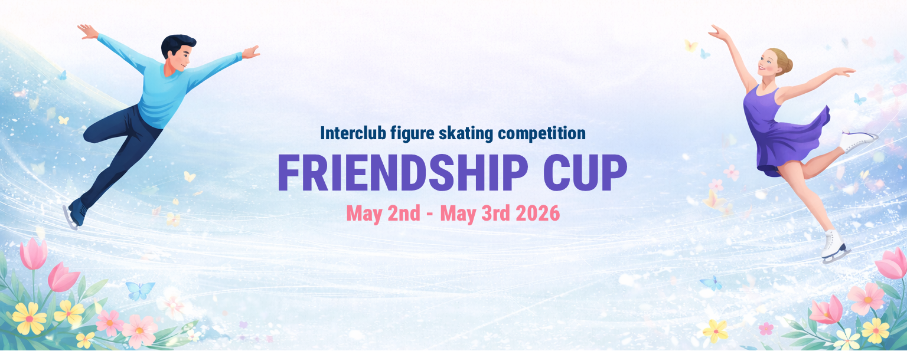

ENTRY FORM
Event time: May 2nd & 3rd 2026
Competition venue: “Mārupes ledus halle”, Kantora iela 128, Mārupe LV-2167
Organizer: Figure Skating club “Daiļslidošanas skola ISPS”

Name of the Club:
ISU Member/Country:
Head coach and contact:
Firstname & Lastname | Phone | E-mail
Participants:

No. | Firstname & Lastname | Date of birth | Category | Subject to discount  (“Native of Mārupes novads” – yes/no)
1.
2.
3.
4.
5.
6.
7.
8.
9.
10.
11.
12.
13.
14.
15.
16.
17.
18.
19.
20.

Entry forms must be sent to e-mail s26@isps.lv latest by the end of 26th of April !

By submitting the entry form, I confirm that I am an authorized representative of the club and that I am submitting this entry on behalf of the skaters listed above. I further confirm that, for each listed skater, I have obtained the informed consent of the skater and/or their parent or legal guardian (where the skater is under 18 years of age) with respect to the following:

- Photography and Videography The skater may be photographed and/or filmed during the competition and related events. Such images and recordings may be used by the organizers for promotional, educational, and archival purposes, including publication on websites and social media.
- Medical and Liability Participation in this competition involves physical activity and carries inherent risk of injury. The organizers, venue, and officials shall not be held liable for any injury, loss, or damage sustained during the competition, except where caused by gross negligence. Each skater participates at their own risk, and the club confirms that each skater is fit to compete.
- Personal Data (GDPR) The personal data provided on this form (name, date of birth, club affiliation, and category) will be processed by the organizers solely for the purpose of administering this competition, including publication of start lists and results. Data will not be shared with third parties beyond what is necessary for competition administration. Participants have the right to access, correct, or request deletion of their data by contacting info@isps.lv

☐ I confirm that all information provided on this form is accurate and complete, and that I have the authority to submit this entry on behalf of the listed skaters and their families.

