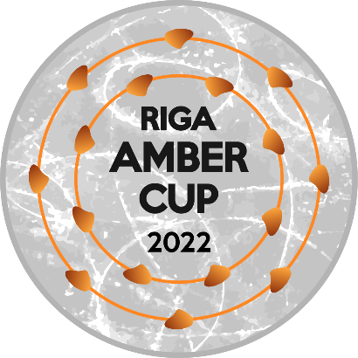

**SYNCHRONIZED SKATING COMPETITION RIGA AMBER CUP 2022**

**Time Schedule**

|  |  |
| --- | --- |
| ***THURSDAY, 15.12.2022*** | |
| **Judges meeting** | **16:00** |
| **Technical panel meeting** | **17:00** |
| **Draw for all categories** | **18:30** |
|  | |
| ***FRIDAY, 16.12.2022*** | |
| **Official practice** |  |
| *Junior* | **9:00** |
| *Senior* | **10:00** |
| **Competition** |  |
| *Junior* | **12:30** |
| *Senior* | **13:15** |
| ***SATURDAY, 17.12.2022*** | |
| **Official practice** |  |
| *Juvenile* | **9:10** |
| *Mixed Age* | **9:20** |
| *Junior* | **10:50** |
| *Senior* | **11:45** |
|  |  |
| **Opening ceremony on ice** | **12:30** |
|  |  |
| **Competition** |  |
| *Juvenile* | **13:30** |
| *Mixed Age* | **13:38** |
| *Junior* | **15:00** |
| *Senior* | **15:50** |
|  |  |
| **Award ceremony on ice** | **16:30** |
|  |  |
| **Round table discussion** | **17:00** |